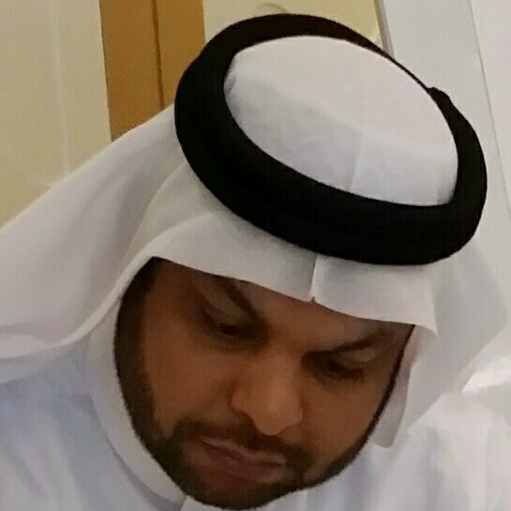
Curriculum Vitae

Personal Information:

Name : Jawad Ahmed ALobed.
CPR No : 750506156.
Nationality : Bahraini.
Date of Birth : 20/5/1975.
Marital Status : Married.
Languages : Arabic, English and handi.
Address : House: 2095 - Road: 335 - Block: 603- Sitra.
Contact : +97333030653, +97333362624.
E-Mail : Jawadhsse@gmail.com.

Objective:

Develop and advance in my career within a challenging and diverse environment, where I can refine my competences and acquire new ones all while striving to excel in the dedicated performance of my duties.

Education Training:

- IOSH Managing Safety from Arabian East Training Centre – 2007.
- General Safety Certificate (Nebosh) – 2008.
- Office Management Diploma from University of Bahrain - 2007.
- Basic Occupational Health & Safety – 2007.
- Diploma Computer from Global Institute – 2000.
- Awareness Training - TUV Nord (ISO 9001:2000) – 2007.
- Accidents prevention Industrial workplaces Attendance Certificate – 2007.
- Emergency Aid at work – 2008.
- First Aid Certificate – 2008.
- Safety Management Techniques - National Safety Council – 2008.

Experiences:

2009 to Until now : Currently working Safety Officer at Ramsis Engineering.
- Monitoring day to day site activates, ensuring that all employee are
following PPE as per safety plan, reporting incidents, tool box talk, etc as per site safety plan

2008 to 2009 : Currently working Safety Officer at GKC Bah Const.

- Monitoring day to day site activates, ensuring that all employee are
following PPE as per safety plan, reporting incidents, tool box talk, etc as per site safety plan

2003 to 2008 : Currently working Safety Officer in charge at Al Nasir Contracting W.L.L.

- Monitoring day to day site activates, ensuring that all employee are
following PPE as per safety plan, reporting incidents, tool box talk, etc as per site safety plan

Personal Skills:

- Fast learner, always seek to expand my knowledge and acquire new professional skills
- Creative thinker and efficient problems solver.
- Good performance under pressure and various challenges.
- Effective member in team working environment.
- Have enough knowledge for efficient planning and analyzing tasks.
- Acquire excellent communication, presentation, problem solving, and creative thinking in addition to leadership skills.

- Computer and technological skills, including:
- MS Offices, C++
- Aspen Plus, Aspen Hysys, Aspen HTFS,
- Polymath
- Matlab
- Knowledge about main hardware & soft ware computer problems.

